Is He/She Having A Stroke?
FROM THE CHIEF MEDICAL OFFICER'S DESK

Strokes can happen to anyone at any time, regardless of sex or age. Each year, nearly 800,000 people in the U.S. have a stroke, and 130,000 die from one. Of those who survive, more than two-thirds will have some disability.

What Is a Stroke?
A stroke occurs when the blood supply to the brain is interrupted or blocked for any reason. Control over movement, perception, speech, or other mental or bodily functions is impaired, and consciousness itself may be lost. Strokes occur in two basic forms, both potentially life-threatening, and the consequences are usually dramatic.
About three-quarters of all strokes are due to blockage of the oxygen-rich blood flowing to the brain. Called ischemic strokes, they are triggered by either a thrombus (a stationary clot that forms in a blood vessel) or an embolus (a clot that travels through the bloodstream and becomes lodged in a vessel).
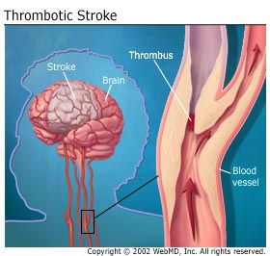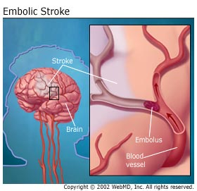
Patients who have a stroke may develop droopiness on one side of the face and/or weakness in the arm (their arm falls to the side and they can’t lift it). If you ask them to smile, it’s not symmetrical.
In general, the best way to tell if someone is having a stroke is to use the acronym FAST:
F Face drooping,
A Arm weakness
S Speech difficulty
T Time to call 911.
If you think someone is having a stroke, ask them to smile, raise an arm, and speak a short sentence. If they are unable to complete any of these tasks normally, CALL 911.
Other common stroke symptoms can include the sudden onset of:
- Numbness of the face, arm, or leg
- Confusion, trouble speaking or understanding
- Vision trouble in one or both eyes
- Trouble walking, dizziness, loss of balance or coordination
- Severe headache with no known cause

When It Isn't Obvious
Knowing when a stroke has occurred may not always be obvious. The classic image of stroke is not being able to move on one side, or to speak. But because some strokes are less severe than others, you might feel only minor weakness in an arm or leg if you’ve had one.
There are two types of stroke; the symptoms are the same:
- ischemic, when a blood clot blocks an artery that carries blood from the heart to the body
- hemorrhagic, when a vessel breaks and stops blood flow to the brain.
As you age, the risk for a mini-stroke -- known as a transient ischemic attack, or TIA -- rises. The symptoms of TIA mimic those of an actual stroke but go away within about 24 hours.
The likelihood that a full ischemic stroke will follow a TIA is strong -- up to 40 percent of people who have a TIA go on to have a stroke. And it doesn’t take long -- 5% of people who have TIA have a stroke within 2-3 days; 10% to 15% have one within 3 months.

Timing Is Key
Getting treatment fast is crucial. You should get to the hospital as soon as possible, because there are treatments that can, in some cases, reverse the damage, thanks to a clot-busting medication (tissue plasmogen activator [tPa]) that can dissolve the blockages that cause ischemic strokes. But there's a catch. The medicine has to be given within 3 to 4 hours of the onset of stroke symptoms for best results. There are other medications to thin blood and prevent clotting even if the 3-hour window has passed, or if a patient can't take tPa. However, timing is critical because the longer the blockage lasts, the greater the damage. Surgery to repair the broken vessel is the go-to treatment for hemorrhagic stroke.
Good News
Eighty percent of strokes are preventable. Almost half of strokes result from high blood pressure. You can take steps to keep it in check -- quit smoking, exercise, lose weight, and take medications your doctor prescribes.

